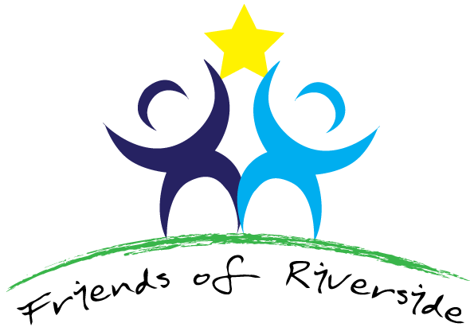

PPG Meeting held on Wednesday, 5th June 2024 at 2.00pm
Present: Dr Sunita Purewal (SP), Christine Croft (CC), Kim Jones (KJ), Jonathan Haydock (JH), Tess Watkins (TW), Helen Rigby (HR), Tony Sackville (TS), and Mohammad Awais (MA).
Apologies: Mohammed Rafiq, Lannie Staff.

1 | Kim welcomed everyone. All introduced themselves and welcomed two new members TS and MA.
2 | Agenda:  - Appointing a chair.  - Recruitment of new PPG members.  - Improving Access.  - Engagement in Buckinghamshire Patient Participation Groups.  The agenda was not followed as it was felt that the aims and objectives of the PPG needed to be shared before these decisions and discussions were had. We only briefly touched on these subjects.
3 | TS asked what the Practice wanted from the PPG?  - Is it a CQC requirement in which case it is just a tick box exercise?  - Does the feedback given by the PPG feedback into the service?  - Do we have a PPG lead within the Practice? If not, then there is no control framework.  TS looked up the PPG Guidance and read out the aims and objectives, practicalities, resources, and support needed to run a successful PPG.
5 | TW asked if we had any questionnaire feedback from patients.  It would be helpful to see these results before the next meeting.
6 | JH and HR agreed they were happy to come along to meetings to give personal feedback to the practice, but neither wanted a more involved role dealing with paperwork, organisation etc.
7 | TW said that she would be happy to interact with other PPG chairs, if KJ could enquire which surgeries had a larger established PPG and were willing for her to visit or speak too.
8 | We briefly discussed the role of the PCN and the possibility of having a joint PPG between the six practices.  KJ will enquire if Cressex surgery are still operating a virtual PPG meeting between the practices.
9 | TS will read the information from Healthwatch Bucks given on engagement in Buckinghamshire Patient Participation groups.  There is a meeting on the 12th June but not sure if can attend.
10 | Date of next meeting:  TS suggested approximately 6 weeks for feedback either via email or teams, once they have the information asked for. Then a more formal meeting in 3 months.  Dates to be confirmed.
11. | Actions required before next meeting:  . Distribute the last Patient Survey results.  (Please see attached link).  https://www.gp-patient.co.uk/PatientExperiences?s=4&practicecode=K82036  . Aims and Objectives for setting up a PPG:  - Contact other PPGs to review how they operate.  - Engage with and attend Bucks Health Watch events.  - Volunteer for Flu Clinics.  - Promote Cancer awareness and NHS Health checks.  - Promote the PPG.  . Send links for other PPG’s.  With her permission we have forwarded Tess Watkins contact details to one of the Managers at Cressex Health Centre, who will consult with Tess and put her in contact with other PPG members.

