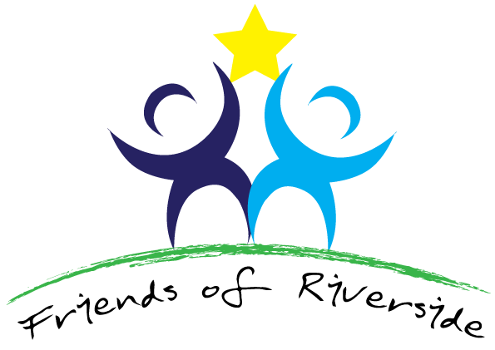

PPG meeting held via Teams on Wednesday, 28 September, 2022 at 1.30pm
Present: Dr. Rashmi Sawhney (RS), Dr. Jo-ai Foley, Dr. Sunita Purewal (SP), Christine Croft (CC), Kim Jones (KJ), Mohammed Rafiq (MR), Jonathan Haydock (JH), Tess Watkins (TW), and Gail Wellings (GW)
Apologies: Dr. Zoe Rogers, and Helen Rigby

1 | Kim welcomed everybody. It had been a long time since our last meeting.
2 | Apologies for Absence: Dr. Zoe Rogers and Helen Rigby
3 | There was no specific Agenda on this occasion. It was basically a catch-up session.
4 | We have new doctor in the Practice who were here today – Dr. Sunita Purewal, Partner. Dr. Roxana Curtis, Partner, who begins officially on 1 October and Dr. Sidhu a new salaried doctor. Other personnel were Ruth – Nursing Associate, who had been there for 18 months; Liz, who had been there for over 18 months and specialised in respiratory nursing; Amy, general nursing including diabetes; Emily, specialising in Women’s Health and Alison Summerfield, specialising in diabetes to help Christine in this increasing area of work. All were experienced nurses. We have additional staff from the Dashwood PCN, a paramedic for over a year – Georgie. Adeel a physiotherapist, Asma, a pharmacist, Sheila, our Care Co-ordinator – a support to patients and a link with Care Homes and we are hoping to have a Social Prescriber starting very soon. All these have enabled the Practice to deal with a wide variety of patient needs. Hopefully this will help us over the winter pressures. In response to a question from JH asking what it would be useful to tell us patients how you feel, RS said that the team is strong and communicative and talks to other Practices which often is very helpful, but occasionally Practices do not communicate. JH then enquired on the effects of stress. This had affected all following Covid and the ability to look after people in any normal way. There are a number of other Surgeries who seem to have upset patients over their treatment during Covid. The situation has been fairly complex. They are trying to recruit some doctors.
5 | TW asked about the Survey Monkey. What was the NHS trying to do? We would only be working within our PCN so that people would be seen by a surgery within our network. RS was asked about how many people had now gone the private route and she said she had no means of knowing but thought not that many. New ideas are discussed and it seems to be a happy work force. TW asked what we patients could do for them and RS replied that what they would like is kindness. That is what makes them feel good. JH asked how they got feedback to them and RS said via the NHS website. Compliments make them feel happy all day. JH asked how one could contact all patients and was told via a Newsletter. MR said that he had heard from other people compliments about patient access at Riverside. RS said there is a new body coming into being – the Buckinghamshire, Oxfordshire and Berkshire Well Being now integrated with social and community care. There is deprivation in some of our County and it is hoped that this new three-County approach will help.
6 | Date of next PPG meeting: ??

