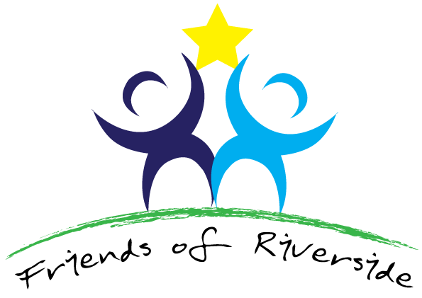

PPG Update meeting between Dr. Jo-ai Foley & Gail Wellings held on Wednesday, 16 June, 2021 at 3pm
Present: Dr. Jo-ai Foley and Gail Wellings
1 | Dr. Foley would be happy to know of anyone else who might wish to join Riverside’s PPG – we particularly need anyone who wished to chair the Committee following Sharon’s stepping down
2 | Apologies for Absence: everybody else
3 | Riverside’s workload, in common with all the other GP Surgeries is very high at the moment. Patient demand has soared. We are entering a third wave. Staff are also impacted due to the necessity of self-isolating if required.
4 | Update on Surgery’s progress on vaccinations, staffing and Projects: We have a new doctor – Dr. Robinson – and two new nurses (Liz, specialist respiratory nurse and Ruth, nursing associate). The vaccination programme had been very successful.
5 | Our PCN (ours is known as Dashwood) had suggested that maybe some of the surgeries could work together on any projects of mutual interest. The Surgeries involved are Riverside, Cressex, Carrington, Chiltern House, Wye Valley and Stokenchurch. There is a proposal to hold wider PCN PPG meetings, rather than individual PPG meetings. The expectation (and hope) is Riverside PPG members would be able to join this and voice their opinions; this will allow surgeries to share the better/worse points of their surgeries so we can all learn together.
6 | Date of next PPG meeting: Suggested some time in September? Via. Zoom again.

