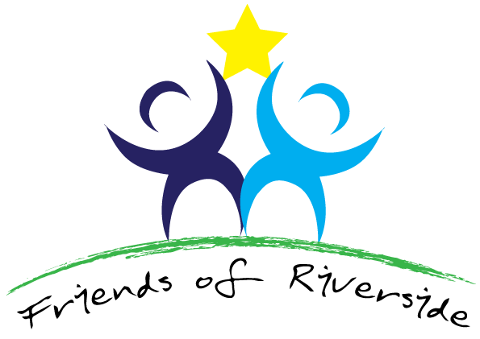

Minutes of a meeting held on Tuesday, 1st October 2019 at 7pm
Present: Jan Snaith (JS) (in the chair), Dr Rashmi Sawhney (RS), Dr. Debra Hemsley (DH), Dr Zoe Rogers (ZR), Dr Jo-ai Foley (JF), Christine Croft (CC), Kim Jones (KJ), Keith Knight (KK), Mohammed Rafiq (MR), Jonathan Haydock (JH), Sharon Colclough (SC), Molly Fowler (MF), Tess Watkins (TW), Helen Rigby (HR) and Lannie Staff (LS)
Apologies: Molly Fowler and Gail Wellings
1 | Jan Snaith welcomed everybody. She also welcomed a new member, Tess Watkins (TW). All were asked why they wished to be a member of the PPG and all responded
2 | Apologies for Absence: as above.
3 | Agenda  . Confirmation of Minutes & Matters Arising  . Bucks and Dashwood Primary Care Launch Event on 18 September 2019  . Healthwatch  . Update on Surgery’s Progress, staffing and projects  . Update on CCG  . PPG Networking Group  . AOB  . Date of next PPG Meeting
4 | The Minutes of the previous meeting were duly confirmed. All were asked if they had used the new phone system and to give feedback. All who had tried it thought it was better. It was reiterated that this new system will save the GPs time.
5 | Bucks and Dashwood Primary Care Launch Event held on 18th September at Cressex Surgery : This was discussed by all. Riverside Surgery PPG was well represented at this event. RS did a presentation. All slides from the event have been circulated. There are 7 key objectives that will hopefully have some numbers and achievements made more clear, so that we will know if this new system of the Dashwood Primary Care Network is successful. Hopefully this new organisation will be better able to reach those hard-to-reach groups in the community, especially in terms of screening. Riverside does well in Breast screening, for example, but not so well in Cervical screening or Bowel screening. Any ideas that any of us have on how to improve reaching these groups, please send them to JS. The Network will receive funding for two new social prescribers (part time) and one new pharmacist this year. Then each year there will be one more pharmacist for the network. There are new projects coming our way in Cancer and Diabetes. ZR will be on the Board of the PCN and RS will continue on the CCG Board in order to keep commissioning and provision responsibilities separate. PCNs now have their own data to be able to set their objectives.
6 | Healthwatch: Helen Smith, the Project Manager of Healthwatch, will attend our next PPG Meeting in January to talk to us.
7 | Update on Surgery’s progress, staffing and projects: The CQC monitoring call happened on 30 September, and there will be an annual call. The 2019 survey will be discussed at the next PPG meeting. There has been the retirement of the Practice Nurse. There is a new Practice Nurse starting and her name is Emily. She has general nursing skills but also Family Planning skills. A very experienced HCA will be undertaking phlebotomy and other duties. A specialist nurse will be with the surgery who is very experienced in Cardiology and Long Term Conditions. Roxanna, GP trainee, will lead on Cancer Screening two days weekly.
8 | Update on CCG: RS gave an update. The CCG is trying to set up an Inequalities Steering Group. The focus needs to shift to patient education. RS is undertaking a Governing Body presentation. Steve Baker used to attend the Governing Body, but not any more. RS will find out what is happening now.
9 | PPG Networking Group: SC said that there will now not be one across Bucks but it made more sense to have PPGs networked across their own PCN. Jan Snaith will contact the Practice Manager at Cressex Practice and ask her to advise on starting this up.
10 | Any other Business: Jan Snaith sadly advised the PPG that she would be stepping down from the Chair at the end of the year. All were sorry to hear this news.
11 | Date of next PPG meeting: Wednesday, 21st January 2020 at 19.00.
 | JS thanked everyone for their time.

